Splunk Core Power User Last Minute Review

🎯 Priority Review Areas:
- Transaction parameters vs output fields — maxspan/maxpause/startswith are parameters; duration/eventcount/closed_txn are outputs
- F.A.C.L.E.T. order — Extractions → Aliases → Calculated Fields → Lookups → Event Types → Tags
- chart vs timechart syntax — chart uses over + by; timechart uses only by with _time always as X-axis
- search vs where — where = case-sensitive, eval expressions, no wildcards; search = case-insensitive, wildcards
- fillnull — default value is 0, syntax is value= before field names
- Workflow actions — only GET, POST, Search (no PUT); escape with $!field$
- Macro definition naming — uses argument count not names: my_macro(2)

🔑 Exam Tips
When you see transaction, remember it auto-creates 3 fields:
- duration — time span of the transaction in seconds
- eventcount — number of events in the transaction
- closed_txn — indicates if the transaction was closed (1) or open (0)
These three come up frequently on the exam. maxspan, maxpause, and startswith/endswith are parameters you configure, not output fields.
- Use stats when you just need calculations/aggregations — it's faster and less resource-intensive
- Use transaction when you need to:
  - See related events as a single event
  - Access the raw text of grouped events
  - Use maxspan/maxpause to define time-based grouping
  - Span across multiple sourcetypes
The exam loves this comparison. When in doubt, Splunk recommends stats unless you specifically need transaction's unique features.
eval creates a new field or overwrites an existing field with the result of an expression
It supports mathematical operators, string functions, conditional functions (if, case, coalesce), conversion functions, and more
eval is used in calculated fields (which are essentially saved eval expressions applied automatically at search time)
Common exam functions to know: if(), case(), round(), tostring(), len(), lower(), upper(), mvcount(), coalesce()
Unlike where, eval does NOT filter results — it transforms them
search vs where cheat sheet:
Feature | search | where
Case Sensitivity | Case-Insensitive | Case-sensitive
Eval Expressions | ❌ No | ✅ Yes
Wildcards | ✅ Yes (*) | ❌ No
Boolean Operators | AND, OR, NOT | AND, OR, NOT
This is one of the most commonly tested concepts on the exam. Burn this into memory:
where = case-sensitive + eval expressions
search = case-insensitive + wildcards.
- | fillnull — replaces nulls with 0 in ALL fields
- | fillnull value="N/A" — replaces nulls with "N/A" (or whatever string you specify) in all fields
- | fillnull value="Unknown" host, source — replaces nulls only in the specified fields with the given value
The exam will likely test whether you know the default value is 0, not "NULL" or "N/A" or empty string. It's a common trick question!
A macro is called using backtick characters: `macro_name` (NOT single quotes!)
Macros can accept arguments: `macro_name(arg1, arg2)`
When defining a macro with arguments, the name must include the argument count: my_macro(2) for a macro with 2 arguments
Arguments inside the macro definition use the dollar sign: $arg1$
A pipe can always follow a macro — think of the macro as just being replaced by its SPL text
Macros are created in Settings → Advanced Search → Search Macros
- Event Type = search string with NO time range, categorizes events with a label. Can have a color assigned. Can be tagged.
- Saved Report = search string WITH a time range, fetches fresh results each time it's run
- Tag = a label assigned to a specific field:value pair. Example: tag the value 10.0.0.1 on field src_ip with the tag internal
How they work together: You can tag an event type! For example, if you have an event type called failed_logins (search: action=failure), you can tag it with security so that searching tag=security returns those events.
This is critical to understand. Splunk applies knowledge objects in a specific order at search time:
"F.A.C.L.E.T."
- Field extractions (first)
- Field aliases (second)
- Calculated fields (third)
- Lookups (fourth)
- Event types (fifth)
- Tags (last)
This means field aliases are available to everything that comes after them in this chain — which is calculated fields, lookups, event types, AND tags. This is exactly why all four answers are correct.
Memorize this order! It shows up in multiple questions on the exam. A handy mnemonic: "F.A.C.L.E.T." — Field extractions, Aliases, Calculated fields, Lookups, Event types, Tags.
chart vs timechart syntax:
chart command:
- | chart <stats-func> over <row-field> by <column-field>
- over = rows (X-axis), by = column split (series)
- Only one field after over, only one field after by
- Alternative: | chart <stats-func> by <field1>, <field2> (field1 = rows, field2 = columns)
timechart command:
- | timechart <stats-func> by <field>
- X-axis is always _time — you never specify an over clause
- Only one by field allowed
- Use span to control time buckets: | timechart span=1h count by status
Key difference: timechart always uses time as the X-axis. chart lets you choose any field.
GET | Opens a URL in a new/same browser window
POST | Sends data to an external web service via HTTP POST (A mix of clear text strings and variables)
Search | Runs a new Splunk search in the same app

What are data models?
- Structured, hierarchical representations of your data
- Designed so non-technical users can build reports using Pivot without writing SPL
- Created by Knowledge Managers or admins for others to use
Three types of datasets in a data model:
- Events — based on a constraint (search filter)
- Search — based on a transforming search
- Transaction — based on a transaction definition
This comes up on the exam! Remember: Events, Search, Transaction (not "lookup" or "pivot" datasets).
Data model hierarchy:
- Datasets have parent-child relationships
- Child datasets inherit constraints from their parent
- Each data model can contain multiple dataset hierarchies
Acceleration:
- Data models can be accelerated for faster Pivot performance
- By default, acceleration is turned off in the CIM add-on
- Only admin or power roles can accelerate data models
What is the CIM?
- A methodology for normalizing data from different sources into a common schema
- It acts as a search-time schema — it does NOT change the raw data
- Allows you to correlate events from different sourcetypes using common field names
What the CIM add-on includes:
- ✅ Pre-configured data models (Authentication, Network Traffic, Web, etc.)
- ✅ Standardized field names and tags
- ❌ NOT custom visualizations
- ❌ NOT automatic acceleration
How normalization works with CIM:
- Uses field aliases to map vendor-specific field names to CIM-standard names
- Example: One vendor logs src_ip, another logs source_address → both get aliased to the CIM field src
- Field aliases are the key knowledge object the CIM relies on to normalize fields
The Field Extractor has two extraction methods:
1. Regex Method:
- Works on any type of data
- You highlight examples of values you want to extract
- FX generates a regular expression behind the scenes
- More flexible but can be more complex
2. Delimiter Method:
- Works when data is structured with consistent delimiters
- Supported delimiters: Spaces, Pipes, Commas, and Semicolons
- NOT supported: Tabs, Colons, Dashes, Equals signs
- Think of it as CSV-style data — clean, predictable separators
Easy mnemonic for delimiters:
"SPCS" — Spaces, Pipes, Commas, Semicolons
Other FX facts for the exam:
- FX is accessed from Settings → Fields → Field Extractions → Open Field Extractor
- You can also access it by clicking on an event and selecting Event Actions → Extract Fields
- FX creates knowledge objects that persist and apply to future searches
- Extractions are scoped to a specific source, sourcetype, or host
Creating a field alias:
- Navigate to Settings → Fields → Field Aliases → New Field Alias
- You select the scope (host, source, or sourcetype)
- You map the existing field name to a new alias name
- The original field is NOT removed — both names work in searches
Overwrite Field Values option:
- When checked: If the alias field already exists, its value gets replaced with the original field's value
- When checked: If the original field is missing, the alias field is removed
- When unchecked (default): Existing alias field values are unchanged
Important distinctions:
- Field aliases are applied at search time, not index time
- They do NOT change the raw data
- They are commonly used for CIM normalization — mapping vendor fields to standard CIM field names
- Remember the order: Field Extractions → Aliases → Calculated Fields → Lookups → Event Types → Tags
Defining a macro (in Settings):
- Name: my_search(2) — number of arguments in parentheses
- Definition (the SPL): index=web status=$status_code$ host=$hostname$
- Arguments field: status_code, hostname
- Arguments use dollar signs ($arg$) inside the definition
Calling/using a macro (in a search):
- Uses backticks (NOT single quotes, NOT double quotes)
- Pass actual values: `my_search(200, server1)`
- A pipe can always follow: `my_search(200, server1)` | stats count
Common exam traps:
- Confusing backticks ` with single quotes ' — macros use backticks only
- Thinking the definition name includes argument names instead of the count
- Forgetting that $ wraps arguments in the definition, not % or #
Transaction parameters vs. output fields:
Parameters (you set these):
- maxspan — max total time for the entire transaction
- maxpause — max gap between consecutive events
- maxevents — max number of events in a transaction (default: 1000)
- startswith — expression defining the first event
- endswith — expression defining the last event
Output fields (automatically created):
- duration — total time span in seconds
- eventcount — number of events in the transaction
- closed_txn — 1 if properly closed, 0 if not
The exam loves testing whether you can tell the difference between what you configure and what the command produces. If you see duration, eventcount, or closed_txn as parameter options — they're traps!
timechart quick facts:
- X-axis is always _time — no exceptions
- Only one by field allowed (unlike stats which allows multiple)
- Use span to control bucket size: | timechart span=1h count by status
- No over clause — if you see timechart with over, it's invalid syntax
- To remove the "OTHER" category: use useother=f
- To limit the number of series: use limit=N
- Default limit is 10 series — everything else goes into "OTHER"
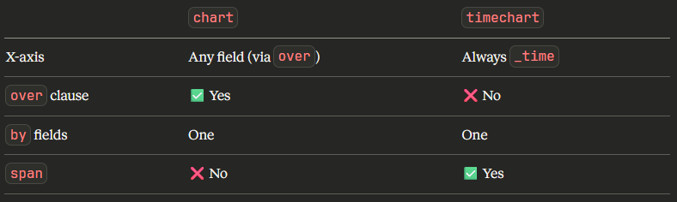
Creating tags:
- Click on a field value in search results → Actions → Edit Tags
- Or navigate to Settings → Tags → New Tag
- You specify: field name, field value, and the tag name
Searching with tags:
- tag=<tagname> — searches all events with that tag on any field
- tag::<field>=<tagname> — searches for the tag on a specific field
- Example: tag::host=production finds events where the host field value has the "production" tag
Tags + Event Types — how they connect:
- You can tag an event type! The field is eventtype and the value is the event type name
- Example: Event type failed_logins → tag the pair eventtype=failed_logins with security
- Now tag=security will return all failed login events
Key distinction:
- Tags = label a field:value pair
- Event types = label events matching a search string
- Tags are more granular; event types are broader categorizations
GET workflow action:
- Opens a URL in a browser (new or same window)
- Passes data via URL parameters
- Example use case: Click an IP → opens a WHOIS lookup page for that IP
- Configuration includes: Label, URL with $field$ variables, link method (new/same window)
POST workflow action:
- Sends data via HTTP POST to an external service
- Payload can include a mix of clear text and variables
- Example use case: Send event data to a ticketing system like ServiceNow
- Configuration includes: Label, URL, POST arguments with key-value pairs
Search workflow action:
- Launches a new Splunk search
- Uses $field$ variables to build the search string
- Example use case: Click a username → search for all events from that user
- Runs in the same Splunk app context
All workflow actions:
- Use $field$ to reference field values
- Use $!field$ (exclamation mark) to escape/URI-encode the value
- Can be restricted to specific event types, sourcetypes, or roles
Key eval functions to memorize:
Conditional functions:
- if(condition, true_val, false_val) — simple if/then/else
- case(cond1, val1, cond2, val2, ...) — multiple conditions, first match wins
- coalesce(field1, field2, ...) — returns first non-null value
- nullif(field1, field2) — returns NULL if values are equal
- validate(cond1, msg1, cond2, msg2) — like reverse case, returns first message where condition is FALSE
Common math/string functions:
- round(value, decimals) — rounds a number
- tostring(value, format) — converts to string (e.g., tostring(bytes, "commas"))
- lower() / upper() — case conversion
- len() — string length
- mvcount() — counts values in a multivalue field
Data models are composed of which of the following dataset types?
Three root dataset types: Events, Search, Transaction
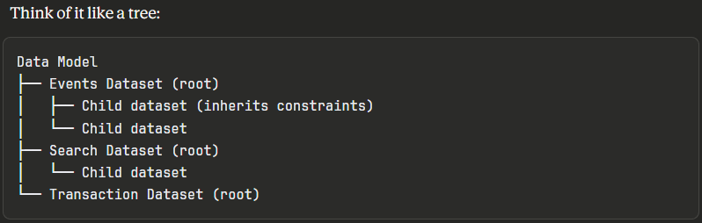
Key facts:
- Events datasets — most common, defined by simple constraints/filters
- Search datasets — use transforming commands, more flexible
- Transaction datasets — group related events by common fields
- Child datasets inherit all constraints from their parent
- Each data model can have multiple root datasets
Data model attributes (fields) come in these types:
- Auto-extracted — fields Splunk extracts automatically
- Eval expression — calculated fields within the data model
- Lookup — fields enriched from lookup tables
- Regular expression — fields extracted via regex
- Geo IP — geographic data from IP fields
Here's how CIM normalization works in practice:
- Vendor A logs firewall data with field src_ip
- Vendor B logs firewall data with field source_address
- A Knowledge Manager creates field aliases:
  - src_ip → src (for Vendor A's sourcetype)
  - source_address → src (for Vendor B's sourcetype)
- Now searching src=10.0.0.1 returns results from both vendors
- The CIM data model for Network Traffic expects the field src, so both sources now map correctly
Why field aliases and not the other options?
- Field aliases don't change raw data — they add an alternate name at search time
- They're applied per sourcetype (or host/source), making them perfect for vendor-specific mapping
- Remember the knowledge object order: Extractions → Aliases → Calculated Fields → Lookups → Event Types → Tags
This is a very commonly tested concept. The exam loves asking what the CIM uses to normalize, and the answer is always field aliases.
Creating a calculated field:
- Settings → Fields → Calculated Fields → New Calculated Field
- You specify: scope (sourcetype/host/source), output field name, and the eval expression
Example:
- Name: velocity
- Eval expression: distance / time
- Now velocity appears automatically in every search matching that scope
Critical connection to the knowledge object order:
Remember F.A.C.L.E.T.:
- Field Extractions
- Field Aliases
- Calculated Fields ← here
- Lookups
- Event Types
- Tags
This means calculated fields CAN reference:
- ✅ Extracted fields (applied before)
- ✅ Field aliases (applied before)
But CANNOT reference:
- ❌ Lookup fields (applied after)
- ❌ Event types or tags (applied after)
Transactions are powerful because they have very few strict requirements:
- ✅ Events MUST share common field value(s)
- ❌ Do NOT need same timestamp
- ❌ Do NOT need same sourcetype
- ❌ Do NOT need same host
- ❌ Do NOT need same source
This is a key reason to choose transaction over stats:
- transaction can correlate events across different sourcetypes
- stats groups events but can't span sourcetypes the same way

Example real-world use case:
| transaction JSESSIONID startswith="action=login" endswith="action=logout" maxspan=30m

This groups all web session events by session ID, regardless of which server or sourcetype they came from, bounded by login/logout actions within a 30-minute window.

Macro syntax summary (know all three!)
The exam tests three different syntax elements for macros. Don't mix them up:
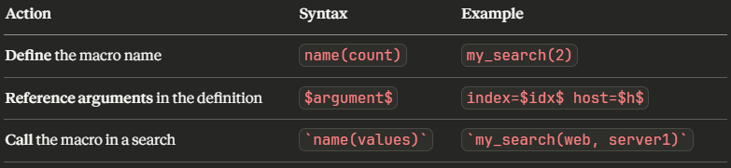
Full example walkthrough:
- Macro name: error_search(2)
- Arguments: index_name, error_code
- Definition: index=$index_name$ status=$error_code$ | stats count by host
- Usage in search: `error_search(main, 404)` | sort -count
Common traps:
- Using single quotes 'macro' instead of backticks `macro` — wrong!
- Putting argument names in the definition name instead of the count — wrong!
- Using $ when calling the macro instead of just passing values — wrong!
Chart/Timechart parameters to know:
Controlling the OTHER category:
- useother=f — removes the OTHER column/series entirely
- limit=N — limits the number of series displayed (default is 10)
- Everything beyond the limit gets lumped into OTHER (unless useother=f)
Controlling NULL values:
- usenull=f — removes the NULL category from results

These parameters work on both chart and timechart
| chart count over host by status useother=f usenull=f
| timechart count by status useother=f limit=5
Display tips:
- To show a chart in stack mode: change Stack Mode in the Format menu
- Trellis layout is enabled via the Use Trellis Layout option in the visualization panel
Quick memory trick: The parameter starts with "use" — useother, usenull. Not remove, not just the word alone.
Workflow action variable syntax:
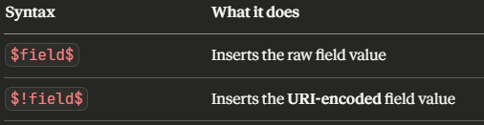

Why does this matter?

Imagine a GET workflow action URL like:
https://lookup.example.com/search?q=$query$

If the field value contains error code 404, the URL would break:
https://lookup.example.com/search?q=error code 404 ← broken!

Using $!query$ encodes it properly:
https://lookup.example.com/search?q=error%20code%20404 ← correct!

The exclamation mark = safety for URLs. This is a frequently tested detail — remember ! = escape/encode.

Data Model Acceleration essentials:
What is acceleration?
- Pre-computes summary data for data models and stores it in tsidx files
- Makes Pivot reports and data model searches dramatically faster
- Trades storage space and processing for query speed
Key facts for the exam:
- Default: OFF in the CIM add-on
- Only users with admin or power roles can enable acceleration
- Acceleration builds summaries over a specified time range (e.g., last 7 days, 1 year, all time)
- Accelerated data models create a summary that updates automatically in the background
- Acceleration is configured per data model in Settings → Data Models → Edit → Acceleration
Why does the exam test this?
- The "determined automatically" options (C and D) sound reasonable and trick many test-takers
- Splunk wants you to understand that acceleration is a deliberate admin decision because of the resource cost
- This question appears on nearly every version of the exam
Tag search syntax:
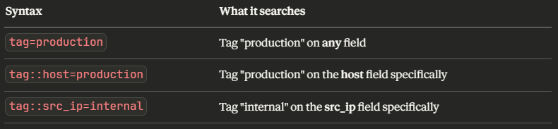
!!!!! The double colon :: is the key!
- tag=value → broad search, any field
- tag::field=value → targeted search, specific field
Other tag facts for the exam:
- A single field:value pair can have multiple tags
- Tags can be enabled/disabled without deleting them
- Tags are applied at search time (last in the knowledge object order)
- You can tag event types: tag::eventtype=security
- Tags are managed in Settings → Tags
Common exam trap: Confusing the syntax order. Always remember it's tag::fieldname=tagvalue — tag first, then double colon, then field name.
case() vs if() deep dive:
if() — simple two-way branch:
| eval status=if(code>=400, "error", "ok")

case() — multiple conditions:
| eval severity=case(
code>=500, "critical",
code>=400, "error",
code>=300, "redirect",
1=1, "ok"
)

Key case() facts:
- Evaluates conditions top to bottom, stops at first TRUE
- Use 1=1 as the last condition to create a default/catch-all value
- If NO condition is true and there's no default, returns NULL
- Order matters! Put the most specific conditions first
Quick comparison:
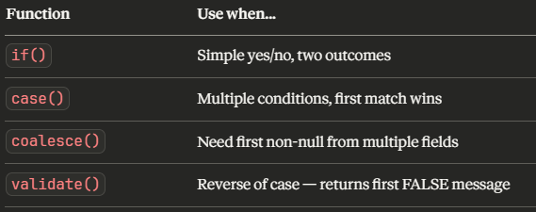

Transaction default values:
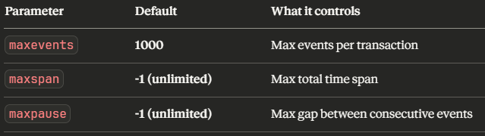

Important nuances:
- If a transaction hits the 1000-event limit, it gets split into a new transaction
- The closed_txn field will be 0 (false) for transactions that were cut off by a limit
- You can override the default: | transaction JSESSIONID maxevents=5000
- This is one reason transaction is resource-heavy — imagine processing thousands of events per group!
This reinforces the stats vs transaction decision:
- If you're dealing with large event groups, stats handles them more efficiently
- transaction with its 1000-event default can silently split your groups, leading to inaccurate results if you're not careful
- Always ask: "Do I really need transaction, or will stats do the job?"

🔑 Exam Tip — FX methods compared:
Regex Method:
- Works on any data format — structured or unstructured
- You highlight sample values and FX generates a regular expression
- More flexible, handles complex/messy data
- You can preview and refine the regex
- Best for: log messages, free-form text, inconsistent formats
Delimiter Method:
- Works only on structured data with consistent separators
- Supported delimiters: Spaces, Pipes, Commas, Semicolons (remember "SPCS")
- Faster and simpler to configure
- Best for: CSV-style data, structured key-value data
How to access the Field Extractor:
- Settings → Fields → Field Extractions → Open Field Extractor
- Click an event → Event Actions → Extract Fields
FX workflow steps:
- Select the sourcetype (or source/host)
- Select a sample event
- Choose Regex or Delimiter method
- Highlight/identify the fields
- Validate against other events
- Save the extraction
Key fact: FX creates knowledge objects stored in props.conf and transforms.conf behind the scenes, but you don't need to touch those files.
Workflow Actions user experience:
Where users SEE them:
- Expand an event in search results → click Event Actions → workflow actions listed there
Where admins CREATE them:
- Settings → Fields → Workflow Actions → New Workflow Action
Configuration options when creating:
- Label — what the user sees in the menu
- Apply to — which event types, sourcetypes, or roles see this action
- Action type — GET, POST, or Search
- Show action in — can restrict to the event menu, field menu, or both
Restricting visibility:
- By event type — only appears on events matching certain event types
- By sourcetype — only appears on events from specific sourcetypes
- By role — only appears for users with certain roles

Important detail: Workflow actions can also appear in the field actions menu (when you click on a specific field value), not just the event actions menu. The "Show action in" setting controls this.
🔑 Exam Tip — Complete CIM picture:
What the CIM IS:
- ✅ A methodology/framework for normalization
- ✅ An installable add-on/app
- ✅ A collection of pre-configured data models
- ✅ A set of standardized field names and tags
- ✅ A guide for Knowledge Managers
What the CIM is NOT:
- ❌ A tool that changes raw data
- ❌ A machine learning system
- ❌ A replacement for field extractions
- ❌ Automatic — it requires configuration by a Knowledge Manager
CIM data model domains to be aware of: Authentication, Network Traffic, Web, Email, Alerts, Malware, Intrusion Detection, Vulnerabilities, Data Loss Prevention, Change Analysis, and more.
How it all fits together:
- Install the CIM add-on
- Knowledge Manager creates field aliases mapping vendor fields to CIM fields
- Tags categorize events into CIM event categories
- CIM data models now work with your normalized data
- Users build Pivot reports on those data models
Transforming commands and their default outputs:
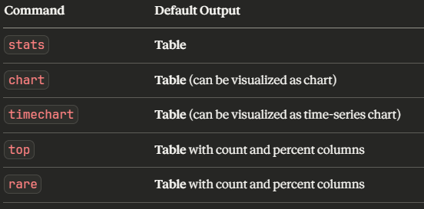

Key insight: ALL transforming commands produce tables by default. The visualization (bar chart, line chart, pie chart) is chosen in the Visualization tab after running the search. The commands themselves output tabular data.
Transforming commands to know for the exam:
- stats — aggregate statistics (count, sum, avg, etc.)
- chart — two-dimensional data (any field as X-axis)
- timechart — time-series data (_time always X-axis)
- top — most common values
- rare — least common values
- eventstats — like stats but appends results to each event instead of replacing
- streamstats — running/cumulative statistics
Choosing the right knowledge object:
This type of "which object should you use" question appears frequently. Here's a quick decision guide:
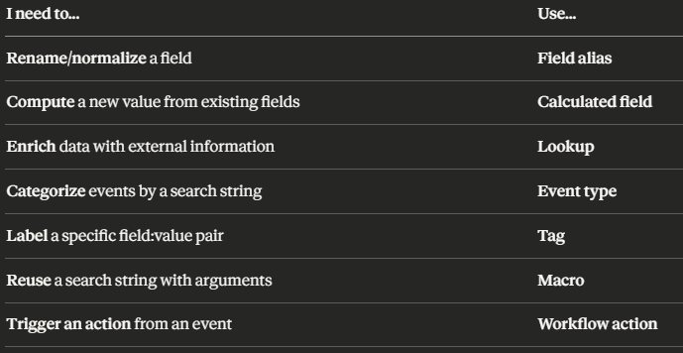
Why field alias is best for CIM normalization:
- It doesn't change the raw data
- The original field src_addr still works
- The new alias src also works in searches
- It's applied per sourcetype, so different vendors can all map to src
- It's the method Splunk officially recommends for CIM compliance
🔑 Exam Tip — Don't confuse these syntax elements!
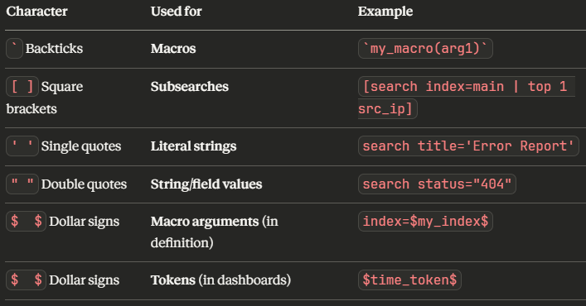
Auto-created OUTPUT fields (appear in results):
- ✅ duration — time span in seconds
- ✅ eventcount — number of events
- ✅ closed_txn — 1 if closed properly, 0 if not
INPUT parameters (you configure these):
- ❌ maxspan — max total time
- ❌ maxpause — max gap between events
- ❌ maxevents — max events per transaction
- ❌ startswith — defines first event
- ❌ endswith — defines last event
Memory trick: The three output fields describe the result of the transaction:
- How long was it? → duration
- How many events? → eventcount
- Did it finish properly? → closed_txn
This same concept has now appeared in questions 1, 16, and 38. The exam will likely have 2-3 questions testing this exact distinction, so make sure it's locked in!
Event Types vs Saved Reports comparison:
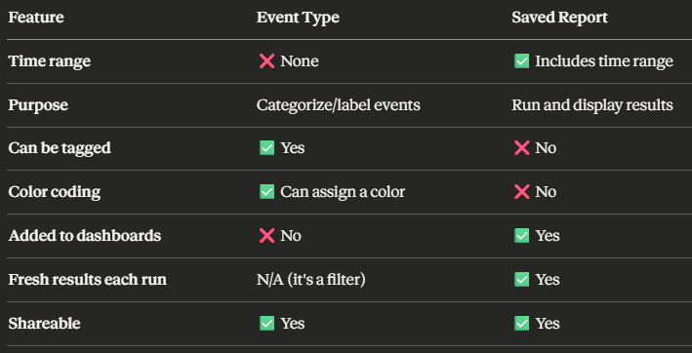
Why no time range on event types matters:
- Event types act as persistent labels that categorize any matching event regardless of when it occurred
- This makes them ideal for classification: failed_login, high_severity_error, network_anomaly
- Since there's no time range, they're reusable across any search or time window

How event types are created:
- Run a search that matches the events you want to categorize
- Save As → Event Type
- Give it a name and optional tags
- Or: Settings → Event Types → New Event Type
The Data Model → Pivot workflow:
Think of it as a two-tier system:
Tier 1: Knowledge Manager / Admin
- Creates and maintains data models
- Defines datasets, fields, constraints
- Enables acceleration when needed
- Ensures CIM compliance
Tier 2: Business User / Analyst
- Uses Pivot to build reports, charts, and dashboards
- No SPL knowledge required
- Simply selects fields, filters, and visualization types
- Works entirely within the data model structure
This is the whole point of data models:
- Bridge the gap between technical Splunk knowledge and business reporting needs
- Knowledge Managers do the heavy lifting once
- Business users get self-service reporting forever
Roles and permissions:
- Admin — can create, edit, accelerate data models
- Power — can create and edit data models, can accelerate
- User — can use Pivot on existing data models, typically cannot create
Complete search vs where comparison:
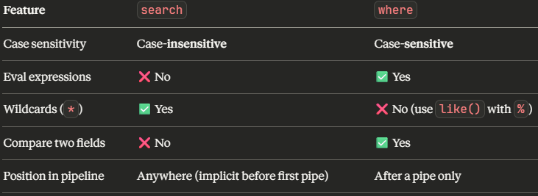
The where command's secret weapons:
- like() for pattern matching: | where like(host, "web%")
- cidrmatch() for IP ranges: | where cidrmatch("10.0.0.0/8", src_ip)
- Field-to-field comparison: | where sent_bytes > received_bytes
- Math in filters: | where (bytes/1024) > 100
Memory trick: where is the power tool — more capabilities but stricter (case-sensitive, no wildcards). search is the everyday tool — simpler but more forgiving.
Workflow action scenario questions:
The exam loves giving you a real-world scenario and asking what happens. Use this decision tree:
"Opens a URL in the browser" → It's a GET action "Sends data to an external service" → It's a POST action "Runs a new Splunk search" → It's a Search action
GET action real-world examples:
- WHOIS lookup: https://whois.com/lookup?ip=$!src_ip$
- VirusTotal scan: https://www.virustotal.com/gui/search/$!file_hash$
- Google search: https://www.google.com/search?q=$!error_message$
POST action real-world examples:
- Create a ServiceNow ticket with event details
- Send alert data to a custom API endpoint
Search action real-world examples:
- Click a username → search all events for that user
- Click an IP → search all traffic from that source
In this question, two clues confirmed GET:
- The URL format (https://whois.com/lookup?ip=...) — it's a web page
- The $!src_ip$ syntax — URI encoding is a GET/URL concern
Data Model attribute types (all five!): The exam asks about these frequently. There are actually five types:
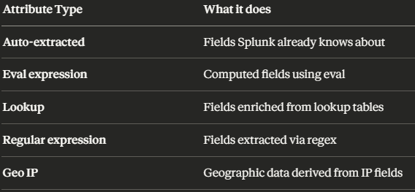
You got all four listed — but remember Geo IP as the fifth! If the exam lists it as an option, it's also correct.
How attributes work in data models:
- They define the fields available in the dataset
- When users open Pivot, they see these attributes as selectable fields
- Attributes can be added at any level in the dataset hierarchy
- Child datasets inherit attributes from their parent
Data model structure recap:
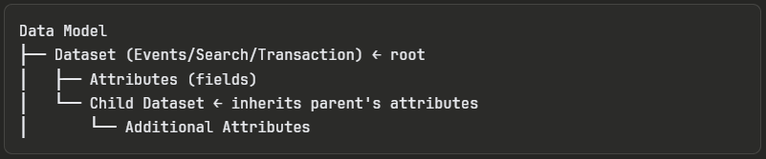
Macro expansion is just text replacement:
Think of macros as copy-paste at search time. Whatever SPL is in the macro definition gets inserted exactly where the backticks are.
Example walkthrough:
Macro name: web_errors(1)
Arguments: min_status
Definition: index=web status>=$min_status$
When you run:
`web_errors(400)` | stats count by host | sort -count

Splunk expands it to:
index=web status>=400 | stats count by host | sort -count

Key facts about macro expansion:
- Happens before the search executes
- The expanded SPL must be valid on its own
- A macro can contain pipes within its definition
- A macro can call other macros (nested macros)
- You can validate expansion using the macroexpand command or Ctrl+Shift+E in the search bar
Handy shortcut: In the Splunk search bar, press Ctrl+Shift+E to preview how your macro expands. Great for debugging!
timechart rules to lock in:
The three strict rules of timechart:
- X-axis is ALWAYS _time — no over clause
- Only ONE by field allowed
- Use span to control time bucket size
✅Valid timechart syntax patterns:
| timechart count ✅ VALID!
| timechart count by status ✅ VALID!
| timechart span=1h count by status ✅ VALID!
| timechart avg(bytes) by host ✅ VALID!
| timechart span=15m sum(bytes) by source useother=f ✅ VALID!

❌Invalid timechart syntax:
| timechart count over host ← no 'over' allowed ❌ INVALID!
| timechart count by host, status ← only one 'by' field ❌ INVALID!
| timechart count by host by status ← can't use 'by' twice ❌ INVALID!

Comparison reminder:
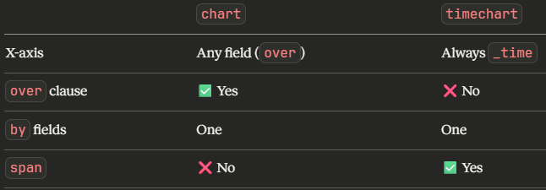

F.A.C.L.E.T. — memorize this!
This is one of the most important concepts on the entire exam:
1. Field Extractions (first -- raw fields are pulled out)
2. Field Aliases (second -- fields get alternate names)
3. Calculated Fields (third -- eval expressions create new fields)
4. Lookups (fourth -- external data enriches events)
5. Event Types (fifth -- events get categorized)
6. Tags (last -- labels applied to field:value pairs)
Why this order matters:
- Aliases can reference extracted fields (extractions come first ✅)
- Calculated fields can reference aliases (aliases come first ✅)
- Lookups can reference aliases and calculated fields ✅
- Event types can reference all of the above ✅
- Tags can reference everything ✅

F.A.C.L.E.T. — memorize this!
But:
- Calculated fields CANNOT reference lookup fields (lookups come after ❌)
- Aliases CANNOT reference calculated fields (calc fields come after ❌)
When to use transaction (the definitive list):
Use transaction when you need to:
- ✅ See raw text of each event in the group
- ✅ Group events across multiple sourcetypes
- ✅ Define start/end boundaries with startswith/endswith
- ✅ See events as a single correlated event
- ✅ Use maxspan/maxpause for time-based grouping
Use stats for everything else — it's faster and more efficient.
Decision flowchart for the exam:
Do you need raw event data? YES → transaction
NO
↓
Do you need startswith/endswith? YES → transaction
NO
↓
Do you need to span sourcetypes? YES → transaction
NO
↓
Do you just need aggregations? YES → stats (always preferred)

CIM data model domains to recognize:
You don't need to memorize every single one, but you should recognize these common CIM data models when you see them:
Security-focused:
- ✅ Authentication
- ✅ Intrusion Detection
- ✅ Malware
- ✅ Vulnerabilities
- ✅ Data Loss Prevention
- ✅ Alerts
Network-focused:
- ✅ Network Traffic
- ✅ Network Sessions
- ✅ DNS
Application/System:
- ✅ Web
- ✅ Email
- ✅ Database
- ✅ Change Analysis
- ✅ Endpoint
NOT CIM data models (common traps):
- ❌ User Behavior Analytics
- ❌ Machine Learning
- ❌ Custom Dashboards
- ❌ Custom Visualizations
- ❌ Scripted Inputs
Quick CIM recall trick: CIM data models cover common IT and security domains. If an option sounds like a Splunk product feature or add-on rather than a data category, it's probably not a CIM data model.
Macro lifecycle in one picture:
Step 1: DEFINE the macro
- Name: host_search(1)
- Arguments: hostname
- Definition: host=$hostname$
- (Dollar signs wrap argument names in the definition)
Step 2: CALL the macro
- Search: `host_search(web01)` | stats count
- (Backticks wrap the call, raw values passed as arguments)
Step 3: EXPANSION at search time
- Splunk replaces $hostname$ with web01
- Expanded search: host=web01 | stats count
The dollar sign trap is very common on the exam:
- $arg$ → only in the definition
- Raw values → when calling
- If you see $value$ in a macro call, it's wrong

Choosing the right FX method:
Use DELIMITER when:
- Data has a consistent separator between values
- The separator is one of: Space, Pipe, Comma, Semicolon (SPCS)
- Data is structured and predictable
- Examples:
  - john|sales|manager|chicago → Pipe delimiter
  - john,sales,manager,chicago → Comma delimiter
  - john;sales;manager;chicago → Semicolon delimiter
  - john sales manager chicago → Space delimiter
Use REGEX when:
- Data is unstructured or free-form
- No consistent delimiter exists
- You need to extract values from within sentences or log messages
- The delimiter is NOT one of the four supported types
- Examples:
  - User john logged in from 10.0.0.1 at 14:30
  - ERROR: file not found [/var/log/app.log]
  - Data delimited by colons, tabs, or equals signs
Exam scenario tip: When the question shows you sample data, first check if there's a clear delimiter from the SPCS list. If yes → Delimiter. If no → Regex.
Tags complete summary:
What tags ARE:
- Labels assigned to field:value pairs
- Applied at search time (last in F.A.C.L.E.T.)
- Can be enabled/disabled without deletion
- Multiple tags per field:value pair ✅
- Multiple field:value pairs can share the same tag ✅
Tagging event types — the power combo:
Event type: failed_logins (search: action=failure)
Tag: eventtype=failed_logins → tagged with "security"
## Now searching tag=security returns all failed login events!

Tags vs Event Types comparison:
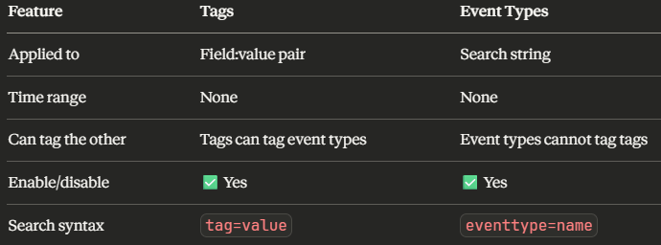

Data model hierarchy in action:
Example:
Root Dataset: "Web Events"
Constraint: index=web
Attributes: host, source, status, uri, bytes
│
├── Child: "Web Errors"
│ Inherits: index=web (from parent)
│ Additional constraint: status >= 400
│ Additional attribute: error_message
│
└── Child: "Web Success"
Inherits: index=web (from parent)
Additional constraint: status < 400
Key inheritance rules:
- Children inherit all constraints from parent
- Children inherit all attributes from parent
- Children can add additional constraints (narrowing the data)
- Children can add additional attributes (more fields)
- Children CANNOT remove parent constraints or attributes
- The hierarchy can go multiple levels deep (grandchildren, etc.)

Why this matters for Pivot users:
- When a Pivot user selects "Web Errors," they automatically get only status >= 400 events from the web index
- They don't need to know SPL — the data model structure guides them
- This is the power of data models: Knowledge Managers build the structure, business users consume it
Order matters in case()!
This is a critical exam concept. Always put the most restrictive condition FIRST:
CORRECT order (most specific → least specific):
case(bytes>1000, "High", bytes>500, "Medium", 1=1, "Low")
- bytes=1500 → checks >1000 first → "High" ✅
- bytes=750 → fails >1000, checks >500 → "Medium" ✅
- bytes=200 → fails both, hits default → "Low" ✅

WRONG order (least specific first):
case(bytes>500, "Medium", bytes>1000, "High", 1=1, "Low")
- bytes=1500 → checks >500 first → "Medium" ❌ (should be "High!")
case() best practices:
- Most restrictive conditions first
- Always include 1=1 as the last condition for a default value
- Without 1=1, unmatched events get NULL
Workflow action configuration fields: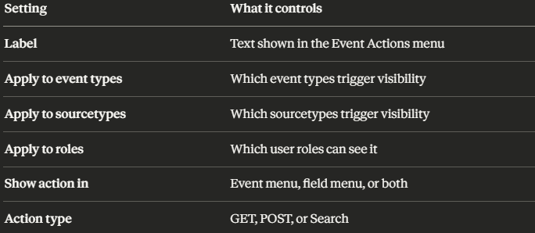
Visibility logic:
- If you specify no restrictions, the action appears for all events and all users
- Multiple restrictions work as AND logic — all conditions must be met
- Example: If restricted to sourcetype firewall AND role security_analyst, only security analysts viewing firewall events will see it
Common exam trap: Time ranges are NOT a restriction option. Remember that workflow actions are about what the event is and who is viewing it, not when it happened.
chart command anatomy:
| chart <function> over <row-field> by <column-field>

Visual representation of | chart count over status by host:
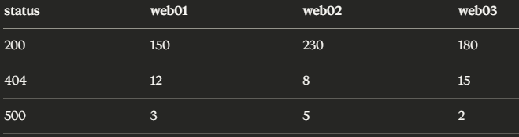
over status → creates the rows
by host → creates the columns
count → fills the cells
Key rules:
- over = ONE field only (rows/X-axis)
- by = ONE field only (columns/series)
- Using both over and by is valid and common
- Alternative syntax: | chart count by status, host (first field = rows, second = columns)
Remember: chart allows over + by. timechart does NOT allow over at all.
Field alias behavior:
Core principle: Field aliases are additive, not destructive. They add a new name without changing anything.
Example:
- Original field: src_addr
- Alias: src_addr → src
- After aliasing:
  - ✅ search src_addr=10.0.0.1 — still works
  - ✅ search src=10.0.0.1 — also works
  - ✅ Both appear in search results
The Overwrite Field Values option (advanced):
- Unchecked (default):
  - If alias field already exists, its value is unchanged
  - Both fields coexist peacefully
- Checked:
  - If alias field already exists, its value is replaced with the original field's value
  - If original field is missing, the alias field is removed
Key facts to remember:
- Aliases are search-time operations
- Raw data is never modified
- The original field always survives
- Aliases are essential for CIM normalization
- Applied second in the F.A.C.L.E.T. order
🔑 Exam Tip — closed_txn values:
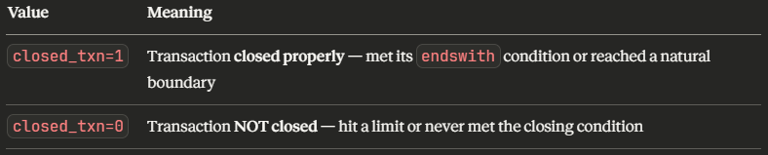
Common reasons for closed_txn=0:
- Hit the maxevents limit (default 1000)
- Exceeded maxspan time limit
- Exceeded maxpause gap limit
- endswith condition was never matched
- Search time window ended before transaction completed
Why this matters in practice:
- If you see many transactions with closed_txn=0, your limits may be too restrictive
- You can filter for incomplete transactions: | where closed_txn=0
- This helps identify sessions that were cut off or never finished properly
All three auto-created transaction fields reviewed:
- duration → how long (seconds)
- eventcount → how many events
- closed_txn → did it finish? (1=yes, 0=no)
Complete macro knowledge summary:
What macros CAN do:
- ✅ Contain any valid SPL including pipes
- ✅ Accept arguments with $arg$ syntax
- ✅ Call other macros (nesting)
- ✅ Be shared across users and apps
- ✅ Be piped to/from other commands
What macros CANNOT do:
- ❌ Execute at index time
- ❌ Accept more arguments than defined
- ❌ Run without proper permissions

Macro quick reference card:
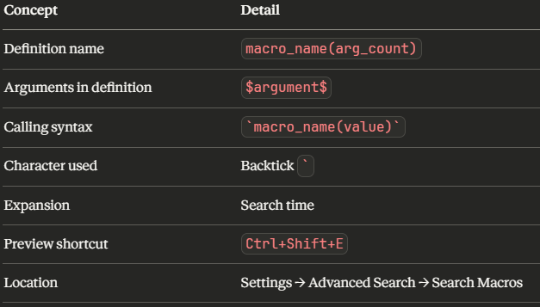
CIM normalization in 30 seconds:
The problem: Different vendors name the same data differently
(Example: Dell) Vendor A: src_ip=10.0.0.1
(Example: Cisco) Vendor B: source_address=10.0.0.1
(Example: HP) Vendor C: s_ip=10.0.0.1

The CIM solution: Field aliases map all to one standard name
src_ip → src
source_address → src
s_ip → src

The result: One search finds all three
search src=10.0.0.1 ← returns events from ALL vendors
Three principles to remember:

- Search time — never index time
- Additive — original fields remain, aliases are added
- Field aliases — the primary mechanism

Roles and data models:
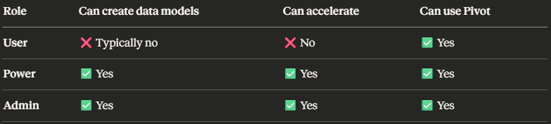
Acceleration reminder:
- Default: OFF in CIM add-on
- Requires power or admin role
- Creates tsidx summary files
- Trades disk space for query speed
- Configure in Settings → Data Models → Edit → Acceleration

The Splunk data model ecosystem:
Admin/Knowledge Manager
→ Creates data models
→ Enables acceleration
→ Maintains CIM compliance
Power User
→ Can also create/accelerate
→ Builds advanced searches
Business User
→ Uses Pivot on existing data models
→ No SPL needed
→ Self-service reporting
Reading SPL pipelines on the exam:
The exam will show you SPL and ask what it does. Read left to right through each pipe:
index=web → Step 1: Get events from the web index
| where status=200 → Step 2: Keep ONLY events where status is exactly 200
| stats count by host → Step 3: Count remaining events grouped by host
Key where behaviors to remember:
- Case-sensitive — where status="OK" won't match "ok"
- Exact match — no wildcards, no partial matching
- Supports eval functions — where len(uri) > 50
- Supports field comparison — where src_ip != dest_ip
- No wildcards — use like() for patterns: where like(host, "web%")
where vs search one final time:
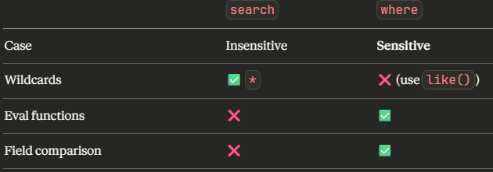

Final workflow action review:
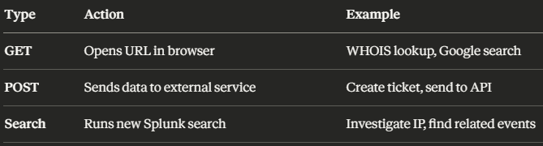
Search workflow action specifics:
- Uses $field$ to insert event values into the new search
- Runs in the same Splunk app context
- Opens results in the search view
- Example: search index=firewall src_ip=$src_ip$ | stats count by dest_ip
- Clicking on an event with src_ip=10.0.0.1 would launch: search index=firewall src_ip=10.0.0.1 | stats count by dest_ip
Remember the three types — GET, POST, Search. No others exist!
🔑 Exam Tip — Searching for knowledge objects:
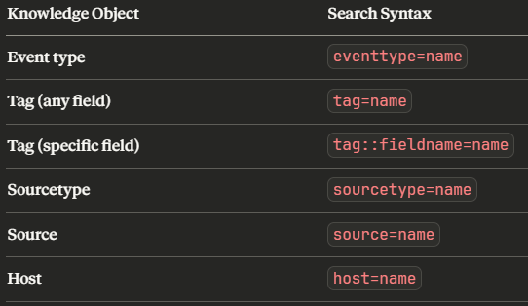
Common trap: The underscore! It's eventtype NOT event_type. This is a frequent exam trick.
Combining event types and tags:
eventtype=web_errors tag=critical

This finds events matching the web_errors event type that are also tagged as critical.

🔑 Exam Tip — Search time vs Index time:
Search time operations (most knowledge objects):
- ✅ Field extractions (FX)
- ✅ Field aliases
- ✅ Calculated fields
- ✅ Lookups
- ✅ Event types
- ✅ Tags
Index time operations (rare, handled by admins):
- Timestamps
- Host/source/sourcetype assignment
- Line breaking
- Default field extraction (metadata)
Why search time matters:
- Changes take effect immediately — no need to re-index data
- Raw data stays untouched
- Extractions can be modified or deleted without data loss
- More flexible but slightly slower than index-time extraction

